Special Relativity
Spring 2006

Foundations of Relativity

The first introduction of a special relativity concept occurs in Maxwell’s equations for the relation between E and B in a vacuum. This equation gave insight to a relation between electric fields, magnetic fields, and the speed of light.

Voigt first introduced the concept of EM waves being observed in a moving frame of reference in 1887 with his “Elastic-Solid Theory” of light and introduced some important mathematical ideas.

Consider the coordinate system and the wave equation

Voigt introduced a moving set of coordinates or “reference frame”
=> Observer frame moving at V in the X direction
and a new time coordinate
where t is unity with no scaling of time and X is a linear function of space.

Voigt demanded that the wave equation preserve its form in the new coordinate frame such that

Therefore

so
clearly we need
then
Transverse coordinates scale in Voigts calculation, however they do not in the Lorenz transformation which will be used for special relativity. This is the main discrepancy between Voigts and Lorenz’s calculations.

Classical reference frames
is obeyed by a free particle

Consider two frames S and S’
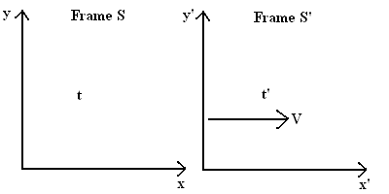

S’ moves with velocity V with respect to frame S, therefore the relation of x between the two frames is , however in the classical explanation, time is absolute between the two frames

The velocity transformation between the two classical frames is given by
And both frames are inertial frames

In mechanics an inertial frame is one where Newton’s first law holds. That is a “free fall frame” in which a particle in that observer frame will continue in a straight line with out accelerating unless an external force is applied to it.

Mechanical Waves

Mechanical wave motion (eg sound waves) results from the Newtonian inertia among the medium which carries the wave.
the speed of a wave measured in S’ is the speed of the wave measured in S minus the velocity difference between frames.

By measuring changes in the speed of the mechanical wave we can detect motion of the host fluid with respect to our inertial reference frame in which the wave is traveling.

Michelson-Morley experiment
Attempted to determine velocity with respect to the either using an optical interferometer.

In the early 19th century mechanical waves were well known, however electromagnetic waver were new. Physicists attempted to use a classical explanation to show that light propagates through an invisible substance called “either”.

By observing EM waves in different inertial frames they hoped to observe the motion of the host medium “either”.

To do this they attempted to measure the speed of the earth with respect to the either by taking one measurement, weighting 6 months and taking another. Since the earth’s orbital velocity is about 3E4 m/s the ratio and that the measured speed of the earth with respect to the either should be on the order of

The Michelson-Morley interferometer consists of a two mirrors at right angles a set distance away from on a splitting cube. If the interferometer is moving with respect to the either, the wavelength on one of the arms will shift and the observed interference fringe pattern will change.

If the interferometer were moving vertically with velocity V with respect to the either
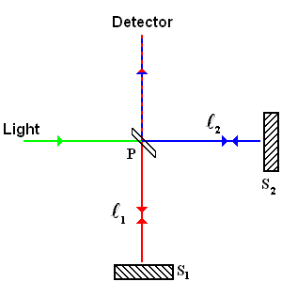
The time of flight can be calculated on the paths PS1P

On path PS2P the observed light path would be at an angle
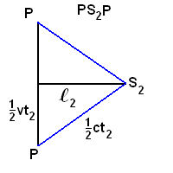

By the Pythagorean theorem

The time difference is now given by
where

Now rotate the interferometer by 90 degrees

The interferometer should register n fringe shifts given by

Since we expect the first order approximation is sufficiently accurate

The number of fringe shifts can be calculated by

where is approximately 1E-4

However the results did not indicate a fringe shift showing that there was no either that light propagated in.

Fitzgerald and Lorentz contractions

Lorentz argued that since the fields of moving charges contracted along the direction of motion, the chemical bonds of matter should contract as well, reducing the object’s length.

In mechanics the Galilean relativity principle was enforced by the Galilean transformation.

in the sense that Newton’s laws hold

However in electromagnetics, Maxwell’s equations do not preserve their form under the Galilean transformation. Following Lamor in 1900 and Lorentz in 1905, Poincare showed that Maxwell’s equations were invariant under the Lorentz transformation.

where

In 1905 Einstein derived the Lorentz transformation from his own axioms involving the principle of relativity and the statement that different inertial observers measure the same value for c.

In the limit where v<<c the Lorentz transformation becomes the Galilean transformation.

Einstein’s axioms allowed all physical phenomena to obey the relativity principle and in particular to enable new mechanics predictions beyond Newton’s laws as V approached c. The Lorentz transformation involves a notion of time that depends on the inertial observer and its consequences should be testable.

Geometric features of space (Galilean) and space time (Lorentzian)

Galilean relativity

In Galilean relativity Newton’ first law is obeyed and time is invariant between reference frames.

In 2d Euclidian space the distance between two points satisfy the Pythagorean theorem.

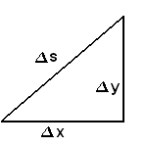

The corresponding metrics in 2d and 3d space are
in 2d space
in 3d space

Invariance
(1)
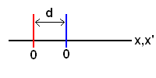
is the same in both frames

(2)
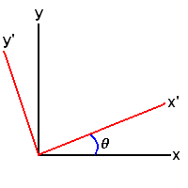

(3)
Moving at fixed time
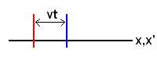
Galilean
for fixed time

Geometry of special relativity

Lorentz transformation
where
ds is the space time interval which is invariant between reference frames
in Rindler where is proper time

Physical derivation of invariance of space time

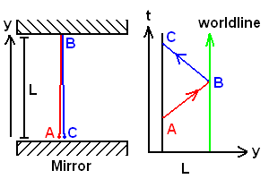

Space time interval between emission at A and detection at C are
,
in an inertial frame moving at V

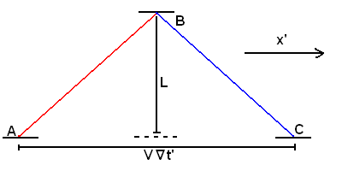

Space time interval is invariant between reference frames.

We now define some special cases of interval
Time like interval
Null interval
Space like interval

Space time diagram

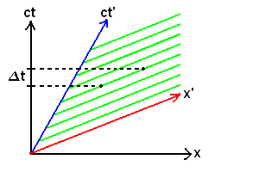

Lines of constant (green) are parallel to and represent simultaneous events as observed in
is observed in non moving frame
is observed in moving frame

x, ct orthogonal, x’ and ct’ appear non-orthogonal in 2 dimensional Euclidian geometry but are orthogonal in the 4 dimensional geometry of space time.
Both (x,t) and (x’,t’) axis’s are properly orthogonal in the proper metric of space time.

Relativistic kinematics

Fitzgerald Lorenz contraction

Consider a rod with proper length as measured in frame in S is measured to be length L is s’ moving a velocity V with respect to S

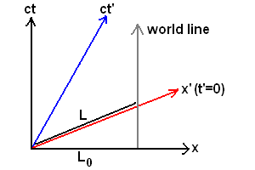

Events -> | 0 in (t,x) | P in (t’,x’)
S | (0,0) | (,L)
S’ | (0,0) | (0,)

Invariance of space time interval

Since the unit of distance should appear larger on the x’ axis when plotted in a 2d plane. We therefore need to calibrate the (t,x) and (t’,x’) axis.

We do this by drawing a space time diagram with a hyperbolic map defining the distance measured in moving reference frames. For any observer frame, the interval will be on the parabola.

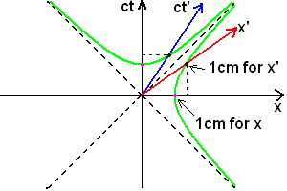

Time dilation

Consider the world line of an accelerating particle

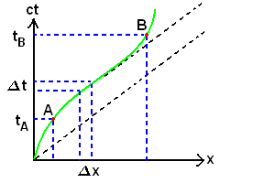

is the “proper time”, time as measured by a clock which is always in the instantaneous rest frame of the “particle” world line. In frame S the same two events are separated by a time .

Clearly
when v is a function of t
when v=a everywhere

when v=0
Therefore “moving clock run slow”

If v(t)=v is independent of time
and
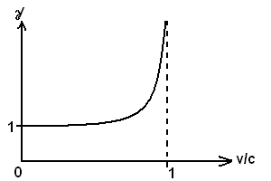

CERN time dilation experiment:
Muons traveling in a 14m circular orbit within an accelerator are measured to have an average lifetime of before decaying as measured in the lab frame when they are at rest. Note that the muon frame is not an inertial frame since it is accelerating (circular).

In the accelerator they travel at V=0.9994C yielding
Their measured decay time is consistent with time dilation

A straight line corresponds to a uniform velocity and generates the longest proper time in space time.
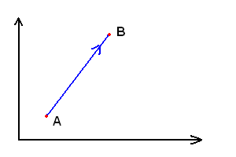
With a uniform v the proper time is
One can make o Lorenz transform to a frame in which this motion appear at rest.
In S’ v=0

Twin paradox
Consider the paradox of two twins. Alice leaves on a rocket that is constantly accelerating while Bob remains on the earth. The rocket accelerates away, slows down and come back. Alice and Bob have followed separate world lines between event leave and return; therefore the measured proper time differs between frames.

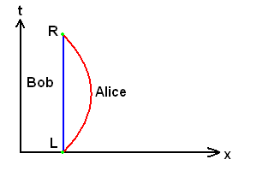
Bob: proper time =
Alice: proper time =
When the twin meet again, Alice is younger then Bob.

The previous problem would require an exact velocity as a function of time, so we look at a simpler approximation. Assume the rocket travels at 4/5C outward, instantaneously reverses and returns at 4/5C.

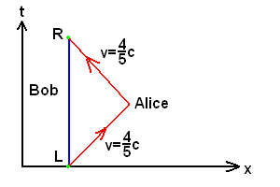
In Alice’s frame
If we suppose the trip took 50 years as measured by Bob, Alice is 30 years older when she returns.

Instantaneous change

In reality no change can instantaneous, however if it occurs in a sufficiently short time the effect on the result will be negligible.
