NRE6102 Plasma Physics
Spring 2006
By Andrew Seltzman

Note convention:

Within these notes T is taken to be kT where k is the Boltzmann constant and T is in Kelvin.

Fusion

To fuse light nuclei, the coulomb repulsion must be overcome by initial kinetic energy. The initial energy is stored in the form of thermal motion of the ions in a plasma. For fusion the ions must collide at approximately .

While fusion relies primarily on collisions, to successfully overcome the coulomb barrier these collisions must be nearly head on. Since the majority of collisions occur at small scattering angles, the confinement time must be large in order to provide a higher probability for a head on collision to occur.

Plasma
A plasma is an ionized combination of electrons and ions that exhibits the following properties:
- Quasineutrality: the average charge over a large volume is 0, therefore the electron and ion densities are equal
- Dimensions exceed the debye length: plasma can provide electrostatic screening of a test charge within it’ volume
- Minimal impurities
- Collective behavior: The plasma acts as a single fluid

Reaction rate
The reaction rate in a plasma is dependant on the ion collision energy and therefore the temperature. The temperature of a plasma has a Maxwellian distribution.
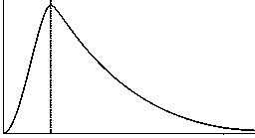
Maxwellian distribution

The reaction rate is calculated from the cross section.
where is the velocity distribution function of a given species.

Fusion Ignition

In a reactor system we want the energy balance to allow alpha heating to maintain fusion temperatures within the plasma without external power input.
In a fusion reaction the neutron carries approximately 80% of the reaction energy and escapes the plasma to be used in power production when it is absorbed externally.

The ignition criterion is given by
where is the fusion energy (3.5MeV for deuterium)
are the radiative power losses and
is the confinement time

Using a best case scenario with no radiative losses, the fusion parameter can be solved for by simple algebra.
is approximately 3E21 keV()
For a tokamak

Plasma

Since plasmas have a high particle density, it is impossible to numerically solve for the interactions between any particle and every other one in the plasma.

Consider a plasma with a non-uniform charge distribution given by the Maxwell-Boltzmann distribution.
for a small exponent the first order approximation is
and the local charge density is
The generated potential is given by Poisson’s equation
where the debye length is

This is the farthest distance that a test charge within a plasma can interact electrostaticly with other particle before its field is screened by the neighboring charges.

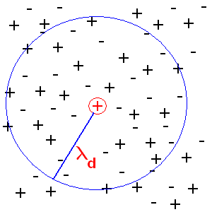

The electrostatic potential of a point charge is given by
so we look for a solution in this form

Within a plasma the potential of a point charge is attenuated exponentially due to the shielding effect from other charges.
This approximates a pure coulomb potential for
We now introduce the plasma approximation

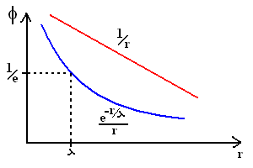

Since the electric field farther then from a particle is attenuated by a factor of e, we can claim that outside of, the particles electric field does not interact with other particles. We further claim that within, the particle interacts with all other particles with a potential function.

At any given point in the plasma, the equation of motion of a given particle is determined by the coulomb scattering and the Lorenz force law.

For the plasma approximation to be valid, it must satisfy the plasma condition. That is to say that the number of particles within the debye sphere must be sufficiently dense to screen out the particles charge, and allow the exponent to be approximates as 1.

Collective plasma effects

Plasma frequency

Consider a section of plasma where you could move a section of electrons between and to the area located just beyond and then release them.

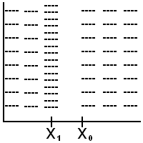

The excess charge at is given by generating an electric field by gausses law for a sheet charge which will generate a force on the charge distribution at , attempting to restore equilibrium.

The equation of motion for this system is given by

The solution to this differential equation (second order homogeneous) is

In other words the electrons will accelerate towards the positively charged area, over shoot and accelerate back causing an oscillation to occur at for electrons and
For fusion plasma is about 1E11 rad/s

Coulomb scattering

Solving the two body motion problem with coulomb forces, we find that as one particle approaches another it experiences a force due to coulomb repulsion. This will cause the particles to deflect and scatter off one another at an angle related to the impact parameter X which specifies the hypothetical distance of closest approach if the particle had not been deflected. Since debye screening is present, we only solve for interactions with particles closer then .

Often we like to work this problem in the center of mass reference frame (right) instead of the lab reference frame (left).

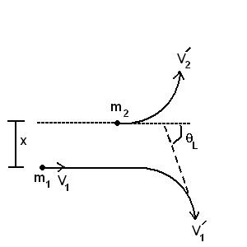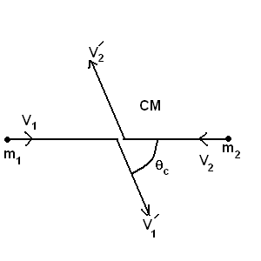

Converting between lab and COM reference frame.

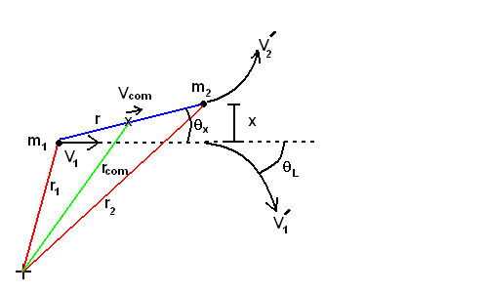

This equation can be solved as

x= impact parameter
= angle in COM reference frame
=phase

The scattering angle can then be derived from

Solving for the lab frame with
Using trigonometric identities, important approximations of this are

Cross sectional scattering area

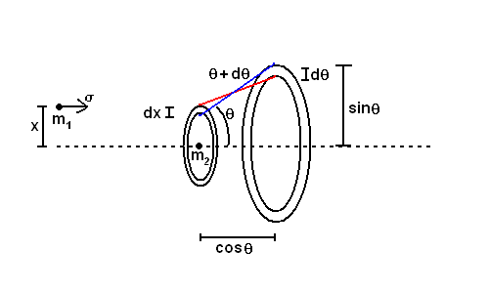

For the previous scattering angle formula we find that particles in an annular ring between x and x + dx will scatter into an angle between and .

For a given particle flux, the amount scattered into the solid angle is defined as the cross sectional area of the annular ring between x and x + dx.

Scattering cross section is given by

Rutherford scattering formula

Large scattering angles

The probability for a 90 degree or greater scattering event is the probability that a particle approaches a second within a disk defined by an impact parameter Xmin that is the largest X that will produce a 90 degree scattering angle.
The critical impact parameter can be derived from
such that

Small scattering angles

By observing the Rutherford cross section we see that is more probable that a particle will scatter 90 degrees through a series of small angle collisions.
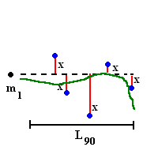

In the limit of small angle collisions (), x and are related by
since in the small angle limit

We can use this formula to define the mean square deflection test

using the substitution
plugging in
integrating over X

We now define the bounds of integration within the coulomb logarithm:
The maximum impact parameter that an interaction can take place over is the debye length since all other charges further away then this are electrostaticly screened out.
The minimum impact parameter is that which will cause a 90 degree scattering to occur. We define this as the upper limit on small scattering angles.

Plugging these values into the solution we say.

We now define the coulomb logarithm.
which is about 15-20 for fusion plasmas

Assuming that the particle velocity is given by

By setting the 90 degree scattering cross section through small angles can be defined as.

By comparing the cross sectional probabilities of small and large angle scattering we find that a particle is about 100 times more likely to scatter through small angle collisions, therefore we ignore large scattering events in our calculations.

Characteristic times

The time required to scatter 90 degrees through small angle collisions can be found by dividing the characteristic length by the velocity. The characteristic time is a good indication of how fast particles will loose organized momentum and reach thermal equilibrium with other particles.

We can use this to determine that an electron beam in a plasma will diverge very quickly, however an ion beam will retain its focus longer, scattering electrons as it passes.

In COM frame

electron->electron about 1E-4s
ion->ion about 1E-2s
electron->ion about 1E-4s
ion->electron about 1s

Energy transfer in collisions

The energy transferred between two particles in a collision can be determined from collision kinematics.

Consider two particles moving at and which is stationary, also M is reduced mass and particles scatter at (particle 1) and (particle 2) in the CM frame and in the lab frame with final velocities and .
Assuming an elastic collision, both KE and P are conserved.
conservation of KE
conservation of P in the x axis
conservation of P in the y axis
Final velocities of these particles are
The energy transfer between the two particles can now be determines as

For multiple small angle collisions and the equation simplifies to

The times of energy equalization are given by
Resistively

Previously we have determined that particle collisions scatter organized momentum.
The equation of motion with scattering included is
The electric field accelerates electrons and ions, while the scattering converts the organized drift into thermal energy among the particles. Since the second term decreases with increasing velocity, electrons which exceed the Dreicer velocity will not be slowed down and will continue to accelerate (runaway electrons).

The current density is now defined as

For the limit where drift velocity is greater then thermal velocity the equation of motion is solved for resistivity.

resistivity

