NRE 4610 Intro to plasma physics and fusion engineering
Fall 2005
By Andrew Seltzman

Basic plasma properties

A plasma must meet 3 criteria to be considered a plasma instead of an ionized gas.

(1) A plasma is a quasi-neutral collection of electrons and ions that exhibits collective behavior. By quasi-neutral it is meant that there are an equal number of free electrons and ions in any given region such that the net charge of that area is 0.

The most relevant effect of quasi-neutrality is that plasma can polarize to screen out an electric field.

Let = the average electron or ion density.
= the actual local electron density

Then the electron density satisfies poisons equation on the macroscopic scale.

The local electron density is then given by

Combining the results we obtain

We now define as the Debye length or distance at which the remaining plasma experiences an inconsequential amount of interaction with the electric field generated by a test charge immersed in the plasma. Any area outside of the Debye sphere is not affected by the test charge.
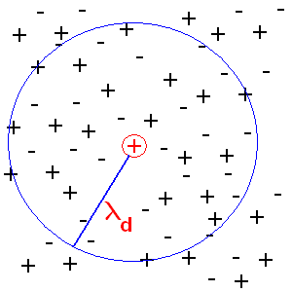

In order to properly screen a test charge, the plasma must have sufficient ionization density. In this case the number of electrons within the Debye sphere must be sufficient to screen the test charge.

= electron density

(2) For a classical plasma (not a weakly ionized gas) the volume must exceed the Debye length.

(3) The number of collisions with neutral particles must be minimal, eg the majority of particles must be ionized.

Plasma frequency

A plasma will exhibit oscillations at a given frequency.

Take a Plasma and displace all the electrons from X1<X<X0 to X1
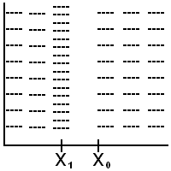

The excess charge at X1 is given by generating an electric field which will generate a force on the charge distribution at X1, attempting to restore equilibrium.
The equation of motion for this system is given by

Which will oscillate at for electrons and

For fusion plasma is about 1E11 rad/s

Coulomb scattering

We now divide the plasma into 2 parts; inside and outside the Debye sphere. Inside the Debye sphere two charged particles can interact and scatter of each other. As one particle approaches another, it experiences a force due to coulomb repulsion. This will cause the particles to deflect and scatter off one another.

Often we like to work this problem in the center of mass reference frame (right) instead of the lab reference frame (left).

Let X= impact parameter (distance of closest approach)

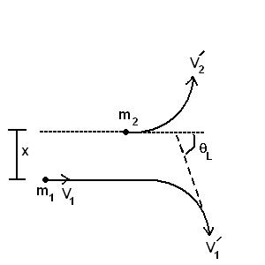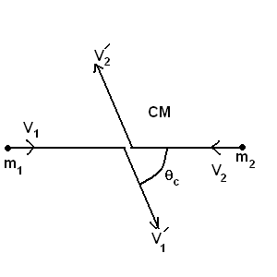

Converting between lab and COM reference frame.

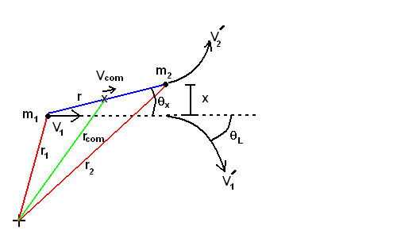

X= impact parameter
= angle in COM reference frame
=phase

Some important limits of this are

Cross sectional scattering area

Rutherford scattering formula =
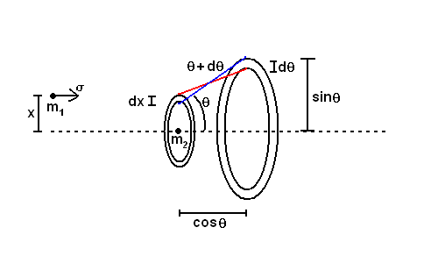

90 degree scattering

Occurs by either of two methods; single or multiple collisions.

Mean square derivation

Particles therefore are more likely to scatter through multiple small collisions.
for a fusion plasma =10-15

Characteristic times

Time for 90 deg deflection in COM reference frame by small angle scattering. This characteristic time is the time it takes for a plasma to loose organized momentum, or for all parts of the plasma temperature to equalize.

In COM frame

electron->electron about 1E-4s
ion->ion about 1E-2s
electron->ion about 1E-4s
ion->electron about 1s

In lab reference frame
m1<<m2
m1=m2
m1>>m2
Most of the time
=> ee,ii,ei

Single particle motion

Resistively: Collisions destroy ordered momentum

The hotter the plasma, the lower the resistance

Gyromotion

An ionized particle will travel in a helix around a magnetic field.
Consider
A particle orbits about the magnetic field axis at the Lamor Radius

Drifts

Uniform B and E

Non-uniform B field
Where is the normal vector to the radius of curvature of the applied magnetic field.

Magneto Hydrodynamics (MHD)

Plasmas as fluids, E and B fields are not fixed.

To analyze plasmas as fluids, we must break up the approximately 1E20 particles per cubic meter into fluid elements in order to simplify calculations.

Particles in a plasma interact with each other due to magnetic fields and Maxwell’s equations.

In a media

Plasma Approximation
The charges in a plasma are too complicated in motion to practically solve for so we use the vacuum equations and approximated the plasma as a fluid consisting of bound charge and assign a current based on their average motion.

Plasma is a non-linear magnetic medium

Convective Derivative

A plasma is considered a fluid and contains electrons, ions, and neutrals.

Define average velocity for a group of particles as:
The charged particles then satisfy the following equation of motion.

However this can not be practically evaluated at all points in space. We want an expression for the change in a quantity at a fixed location in the lab reference frame.

This equation is known as the convective derivative

Where is the change at a fixed point in time and is the change due to moving to a new location.

For a plasma the convective derivative is written as:

Thermal motion in the plasma causes pressure due to collisions, while electric and magnetic fields allow the ions and electrons within the plasma to interact with each other.

Consider right moving particles in the diagram. The number of particles entering boundary A is

where P is the number of particles

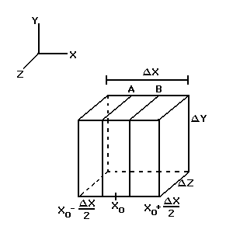

where P is the number of particles

Consider the case of left and right moving particles, the left moving particles carry momentum in the –x direction, while the right moving particles carry momentum in the +x direction.

More specifically particles carry momentum in the direction.

The total change in momentum at is
Now decompose particle velocity into average fluid velocity and random thermal velocity.

Thermal Velocity

The continuity equation now reads
rate of change in particle density = -flux through cube’s surface

where P is pressure
Likewise in 3 dimensions

when taking scalar pressure into account

To account for Y momentum transfer in the X direction we define the pressure tensor

and replace with

Collisions with Neutrals

Momentum from the plasma is exchanged with that of the neutrals.
Let
plasma fluid velocity
neutral fluid velocity

Momentum exchange is proportional to the relative velocity with a mean free time between collisions . Therefore the force between the neutrals and the plasma is leading to:
for plasmas with neutrals

Continuity (Mass Conservation)

Total number of particles N enclosed in a volume bounded by surface S can change only if there is a net flux through the surface.
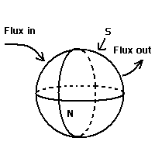
Since volume V is arbitrary
Continuity equation

Equation of State
From thermodynamics, we take where
for constant C
thus and and is valid when thermal conductivity is low
Complete set of Equations for MHD

Fluid Drifts

In the fluid elements there exists a term not present in the particle drift equations. Fluid elements are made of particles and are expected to drift perpendicular to B.
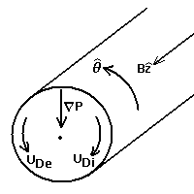

Neglecting the term the diamagnetic drift is
And is valid for (this happens when and ), otherwise enters the expression.
When the plasma is isothermal (), , generally so
Therefore
in a plasma cylinder
Drift current is defined as
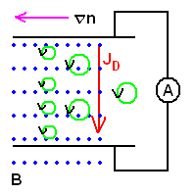

Other Fluid Drifts

ExB drift for fluids

Curvature drift as the plasma follows a curve in the B field

B Drift does not exist for a fluid.

Parallel Drift occurs parallel to B. For we have Ignoring the convective term since the potential is nearly uniform
fluid is accelerated along B
When this is isothermal and can be integrated,

Boltzmann Relation (balance of electrostatic and plasma pressure)

Drift Summary

Drift | Particle | Fluid | Charge Separation
ExB |  |  | No
Curvature |  |  | Yes
B |  | none | Yes
P | none | or | Yes

Plasma Waves

Equilibrium and Transport

Plasma equilibrium and momentum balance are determined by the Lorentz force which is generates a magnetic field in a plasma column carrying current.

This magnetic field balances out the pressure gradient in the confined plasma column.

Solving for the last two equations, we find that there exist constant pressure surfaces, or Isobaric surfaces (Flux surfaces) within a plasma column.

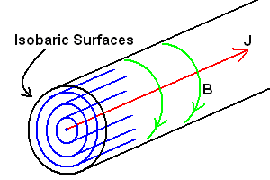

An ion in the plasma is therefore constrained to move along an isobaric surface. The particle can be transported along the plasma columns length and around the column at a constant radius. In reality the particle gyro rotates along a magnetic field line that lies on the isobaric surface, exchanging field lines with other particles due to collisions.

In a Tokamak a plasma column is subjected to a toroidal magnetic field which is used to prevent pinch and kink instabilities. In a column approximation, an axial magnetic field travels along the length of the column, causing the ions and electrons to rotate about the center along a corresponding isobaric surface, generating the diamagnetic current.

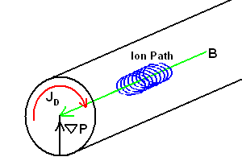

The net current is determined by the density of ions and electrons.

Diamagnetic current

In a plasma a pressure balance exists.

This is usually small and approximately 0 for straight lines.

Where kinetic pressure
We now define the factor.

Transport

In a magnetically confined plasma, ions and electrons will gyro rotate about the magnetic field line that they are traveling on. When two particles collide, they are knocked to separate field lines. The result of this is particle transport across isobaric surfaces. The net displacement generated by this process is a random walk given by.
where is the lamor radius.
The radial transport across a flux surface is

Diffusion
Given a volume of particles, area A and width dx subjected to an incoming particle flux.
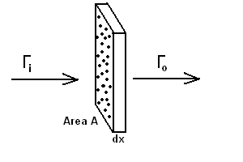
# of atoms in slab
Fraction of area blocked
Incoming flux
Outgoing flux
Where average velocities and times are:
Mean free path
Time

Re deriving the radial transport equation

Momentum exchange Ri between particle species i and all others j

Ficks Law

for
Radial current vanishes for a plasma column

Confinement Concepts

Simple Magnetic Mirror

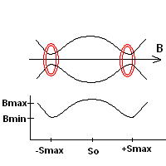

A simple mirror consists of 2 magnetic coils a set distance apart that trap plasma with drifts.

Since the stationary magnetic field does no work, conservation of KE requires that
Where is the gyro motion velocity.
Likewise conservation of angular momentum requires that
this is conventionally written as
Combining the two relations

In order for a particle to be trapped, for that is before the particle reaches the end of the mirror and falls through the coil.
Evaluating the expression at
Loss cone

The boundary velocity of a particle trapped in a mirror is given by
The slope of this equation generates the loss cone of the confinement system.
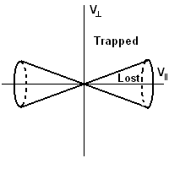

Particles initially below a certain will be immediately lost as well as those scattered into the loss cone.

The confinement time of a given mirror system is given by

The simple mirror is unstable against flute instabilities. If the surface of the plasma is deformed outward, the kinetic pressure will remain constant, however since the plasma is now further from the magnetic coils, the restoring magnetic pressure is weaker, and the plasma will continue to deform until confinement is lost.

Minimum B Mirror

Flute instabilities can be suppressed if the magnetic field increases farther from the center of the plasma, applying a proportional correcting force to reestablish confinement.

A minimum B mirror consists of a pair of cresset shaped coils (similar to a baseball) that confine plasma in a spherical region.

Tandem Mirror

To prevent loses out of the ends of the simple mirror, it is possible to form an electrostatic plug at the ends of the magnetic coil by augmenting the design with minimum B end plugs. In a mirror configuration, electrons escape confinement faster then ions, so the mirror operates with a net positive charge. By creating a higher plasma density at the ends of a simple mirror by use of minimum B end plugs, the imparted potential difference repels ions back into the mirror, increasing confinement time.

Tokamaks
To compensate for confinement losses in the simple mirror, the magnetic field was bent into a circular path, forcing the plasma column to form a torus. This type of closed confinement concept is called the tokamak.

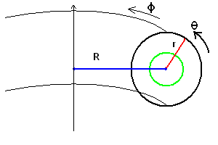

The Pappus--Guldinus theorem says that:

The area of the surface of revolution on a curve C is equal to the product of the length of C and the length of the path traced by the centroid of C (which is 2 the distance from this centroid to the axis of revolution).
The volume bounded by the surface of revolution on a simple closed curve C is equal to the product of the area bounded by C and the length of the path traced by the centroid of the area bounded by C.

Where the centroid in a given axis is:
The area and volume of a tokamak (torus) is

The Tokamak traps a toroidal plasma column in several magnetic fields arranged to confine and stabilize the plasma column.

Tokamak Confinement

A tokamak operates with the superposition of 3 independent magnetic fields; a toroidal field (), a poloidal field (), and a vertical field with curvature about the direction.

The most obvious way to make a charged particle follow a toroidal path is to provide a toroidal magnetic field, however confinement is not possible with a toroidal field alone since the curvature and drifts would cause charge separation in the plasma. The ions would drift up, while the electrons drift downward, inducing a downward electric field. This downward electric field, overlapped with the toroidal magnetic field causes an outward radial drift () forcing the plasma into the reactor walls.

To compensate for this, a poloidal field generated by a toroidal current flow within the plasma, confines the plasma column to a toroidal geometry and cancels out the drift.

Due to the toroidal curvature of the toroidal plasma geometry, the poloidal field is stronger near the center of the torus then it is near the exterior. This provides an outward force in the pressure balance equation since the magnetic pressure is weaker towards the outer surface of the tokamak.

Magnetic Field Superposition

The poloidal field is generated by the toroidal current flowing within the plasma and compresses the plasma to a toroidal column, confining the plasma. This however causes pinch and kink instabilities.

The toroidal field is generated by toroidal field coils (wrapped around the plasma’s axis) and stabilizes the plasma instabilities by forcing the plasma to follow a toroidal path.

The toroidal field within the tokamak is given by

Due to the decrease in poloidal field strength with radius, the pressure balance attempts to force the plasma into the outer wall, this is compensated by adding a vertical field.

The vertical field is generated by the central solenoid and prevents outward drift of the plasma. The vertical field also possesses curvature which prevents vertical drift. As the vertical field is generated by the central solenoid, the increasing magnetic flux induces a toroidal electric field which produces the toroidal current.

Stability
In plasma columns confined by carrying current, two main types of instabilities exist; pinch and kink instabilities.

The current carried by the plasma is constant, therefore as the dimensions of the plasma column change, the current density increases and the total current is contained entirely within the plasma’s surface. The poloidal magnetic field generated by the enclosed current is then given by amperes law.
Pinch Instability
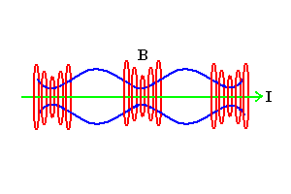
If a plasma column experiences a perturbation in the form of a radial compression of expansion, the magnetic field at the surface increases or decreases, increasing or decreasing the magnetic pressure at the surface. The perturbation will therefore continue to grow.

Kink Instability
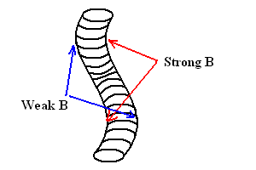
If a plasma column experiences a perturbation that causes it to bend, the expanded section will experience a weaker restoring magnetic pressure and continue to expand. Likewise the inner section will continue to contract.

Safety Factor

To prevent the instabilities in plasma columns generated by purely poloidal magnetic fields, toroidal fields are applied to prevent pinch and kink instabilities. The ratio of poloidal and toroidal field magnitudes is given by the safety factor.
The safety factor is geometrically defined as the number toroidal revolutions for every poloidal revolution.

Suppression of internal kink instabilities requires

Suppression of surface kink instabilities (r=a) requires

By superposition of magnetic fields this specifies that for a tokamak, the toroidal field must be greater then the poloidal field.

The safety factor constrains the maximum current that a plasma can carry wile maintaining stability.

Plasma Heating

Ohmic Heating

Since a plasma is a resistive medium, it can be ohmically heated by a current flow.
The resistance of a plasma is:
where

For a uniformly distributed current, this can also be written as

Using the definition of the safety factor and amperes law

Ohmic heating can be written as

This implies that it becomes progressively more difficult to resistively heat high temperature plasmas, and that resistive heating can achieve a higher temperature in high field tokamaks.

Neutral Beam Injection

Plasma can be heated by kinetic energy exchange with high velocity beams of deuterium fuel. Deuterium is ionized and accelerated electrostaticly across a potential difference, however to be injected through the magnetic fields of the tokamak, it must first be neutralized so there is no Lorenz force in the beam.

The ionized beam is guided through a neutralizer gas where it gains electrons from the neutral deuterium. Any ionized portion of the beam is magnetically directed into a beam dump and the remaining neutral beam is injected into the tokamak.

The mean free path of the neutral beam is
For effective heating the majority of the beam energy must be deposited at the center of the plasma (), so the beam energy must be greater then

RF Heating

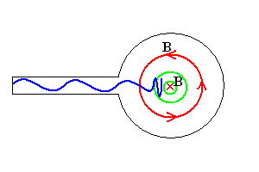
An electromagnetic wave is launched into the plasma using a waveguide or antenna. As it passes through the plasma the magnetic field varies with position, determining the resonant frequency of the plasma at that point.
When the wave reaches an area of the plasma where its frequency matches the local resonant frequency, it is absorbed and drives electron or ion oscillations in the plasma thereby heating it.

For RF waves propagating parallel to the magnetic field, the resonant frequencies are given by the ion and electron cyclotron frequencies. This type of heating is called ECRF and ICRF.
where e and m are either the ion or electron charges and masses

For RF waves propagating perpendicular to the magnetic field, the resonant frequencies are given by upper and lower hybrid frequencies.

Plasma Wall Interaction

Surface Erosion

Electrons or ions colliding with the surface of a material can remove atoms from the surface by sputtering. A particle colliding with the surface of a material will transfer its kinetic energy to the lattice of the material. If at any time the energy of a given lattice atom at the surface of the material exceeds its surface binding energy, it will be sputtered and escape the surface.

The rate of atomic sputtering scales directly with the mass of the incident particle, further, below a certain threshold energy, sputtering will not occur. This threshold is given by the minimum incident particle energy that will cause sputtering.
where is the surface binding energy

Impurity Radiation

Impurities in a plasma will cause energy losses in the form of EM radiation by several methods; Bremsstrahlung, line and recombination losses.

Bremsstrahlung

When a charged particle is accelerated, it will emit EM radiation. In the case of a fusion plasma, this will be caused by electrons colliding with impurity.
The energy of the EM radiation given off by an accelerated charged particle is
The coulomb force of an impurity ion on an electron is
Taking place over time and distance x
and produces acceleration
The total Bremsstrahlung power radiated is given by integrating over all interactions in the plasma volume
Line Radiation

Electrons in a plasma collide with partially ionized impurities and excite their outer electrons to the next highest orbital. The electron will then decay back to its ground state, emitting a photon at the atoms characteristic line frequency.

Recombination Radiation

Free electrons within a plasma can recombine with ionized impurities, emitting the ionization energy difference as a photon.

