ece3085 Systems and Controls, summer 2005
Dr D. G. Taylor

Class notes by Andrew Seltzman
www.rtftechnologies.org

Graphs and figures were gleaned off the web, Axis titles may not match the notes.

This class will cover:
- Linear continuous and discrete time system analysis for feedback and control system design.
Control systems are used whenever a desired system attribute or variable is to be maintained with in a certain range.

Notation:

Time indices:
t = continuous time (real valued)
k = discrete time (real valued)

System variables:
u = system input (scalar or vector)
y = system output (scalar or vector)
x = system state (usually a vector)

Unit step signals:

Continuous time: u(t) (in this class we will also use 1(t) to represent a unit step)
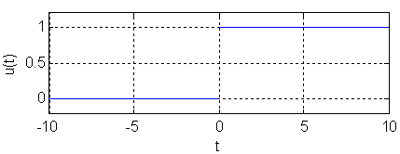
Discrete time: u(k) or 1(k)
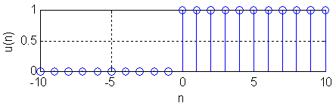
- Properties of linear systems:

Causality: A system obeys causality (or is causal) if the response does not precede the input (no output before input). Physical systems and filters that process signals in real time are causal.
Linearity: A system is linear if it obeys the properties of supersition and linearity. Eg, multiplying an input by a constant will result in the output being scaled by the same factor. Adding two signals before connecting them to the system input will result in the same output as sending the two signals through two identical but separate systems and then adding the outputs.
Time invariance: The designation of t=0 is arbitrary.

In this course we are primarily concerned with systems that are linear and time invariant. We call these linear time invariant systems or LTI systems.

- Discrete convolution:

The impulse signal is defined as
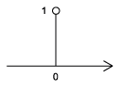
The impulse response of a is the output of a given system when an impulse is applied to the input.

Impulse response is defined as

Consider an arbitrary input of the form:

Input output pairs:

By definition of time invariance we have:

Therefore we can define the summation:
by linearity

The zero state response (when dealing with a causal system) can therefore be defined as:
(since by causality, h(k-i)=0 for all (k-i)<0, i>k )
We only need to add up to k since a causal system can not anticipate an input that has not yet occurred.

The convolution sum for the above system can now be modified using a change of variables:

The complete response for any system is given by:
(Complete resp) = (zero input resp) + (zero state resp)

Previously (in DSP) the convolution only attributed for the zero state response, however to determine the compete response we require knowledge of the zero input response as well.

- Continuous Time

Convolution
In continuous time the dirac delta is represented as an impulse lasting in length with magnitude .

Taking the limit as approaches 0, it is noted that
Unlike the mathematical representation of the dirac, in a causal system the width epsilon is located only in the positive time interval instead of equally on both sides.
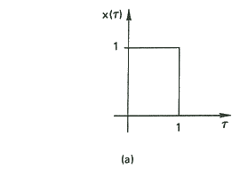
And the delta function can now be represented as an impulse with total area of 1 occurring at t=0
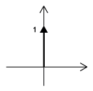

This property is observed when the integral of the dirac function evaluates to 1
A further use of the dirac is the extraction of function values.
The integral of the product of a function and a dirac evaluates to the functional value at the time when the impulse occurs, assuming the function is continuous at that time. This can be used to extract any value from the function.

Impulse Response
The impulse response is the zero state response (eg condition = 0 initially)

For arbitrary positive time input, a signal can be represented as
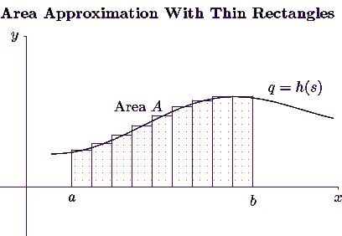
In this case each step size is in width.

Now we can state

Recall that this is now a Riemann sum:

In the limit where approaches 0

The continuous time convolution integral is now defined as:
We only need to integrate up to t due to causality.

Z Transform

There are two forms of the Z transform, the one sided and the two sided transform.

One sided
Two sided

For causal systems we will only use the one sided version of the z transform since all values of f(k)=0 for negative values of time.

Recall that in the radius of convergence

Let f(k) be the following signal:

Now consider the following signal

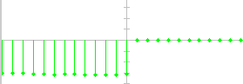

This presents a problem since different signals yield the same z transform

Conclusion: if f(k) is not a positive-time sequence, then the region of convergence (ROC) must be specified.
For positive-time signals, the z transform may be applied and the ROC may be disregarded.

Example:

Properties of the Z Transform

Linearity:

Multiplication:

Exponential:

Time Delay:

Time Advance:

Convolution:

Laplace Transform

When executing a Laplace transform we include and we usually know the system state at

Example

Example
We now must find the limit

Example
For a=0

Example

Previously in DSP, we only considered zero-state responses, (assumed that the system was in x(0)=0)

In ECE 2040 we introduced the Laplace transform and began to consider both the zero state and zero input response, taking into consideration non-zero initial conditions.

Laplace Transform

For a causal system, we can use a one sided version of the Laplace transform since all input signals are 0 for t<0
Properties of the Laplace Transform

Linearity:

Convolution: Used to compute the Zero State Response (ZSR)

Zero State Response
For a causal LTI system
ZSR:
Input: u(t)
Output: y(t)
Impulse response: h(t)

Differentiation:

Laplace of an Impulse:

Laplace of 1(t)

Since s is complex we must now find the region of convergence.

We see that the term will never converge; the phasor will just precess about the unit circle, therefore as the limit exists if and only if .

Then

The significance of this relation to the Laplace transform, is that for causal systems, no two Laplace transforms will map to the same F(s)
Therefore for causal systems, the ROC can be ignored since a causal system always has Re{s}>0

It should be noted that the ROC depends on the signal itself:
Positive time signal: Re{s}>0
Negative time signal: Re{s}<0

In this class we will only study signals that start after t=0, for example we will never see but we will see

Example

The limit exists only in the region of convergence, defined as

