Tektronix 3012B DSO Oscilloscope
Quick Start Guide

Andrew Seltzman
Georgia Institute of Technology
School of Electrical and Computer Engineering
6/7/2005

Tektronix 3012B DSO Oscilloscope Overview

- The Tektronix 3012B Oscilloscope allows accurate measurement of signal parameters with automated measurements and on screen cursors. Further, the provision of a built in FFT analysis algorithm and advanced trigger settings allows complex signals to be accurately observed and analyzed.

Specifications
- Bandwidth: 100 MHz
- Vertical sensitivity: 1 mV - 10 V /div
- Time base range: 4 ns - 10 s /div
- Trigger filtering: DC, HF Reject, LF Reject, Noise Reject
- Input coupling: AC, DC, GND
- Input impedance: 1 Mohm in parallel with 13 pF or 50 Ohm

Tektronix 3012B Front Panel Controls

On Screen Menu Buttons are located directly below and to the right of the display screen. When pressed, the button will activate the corresponding function within the LCD display.
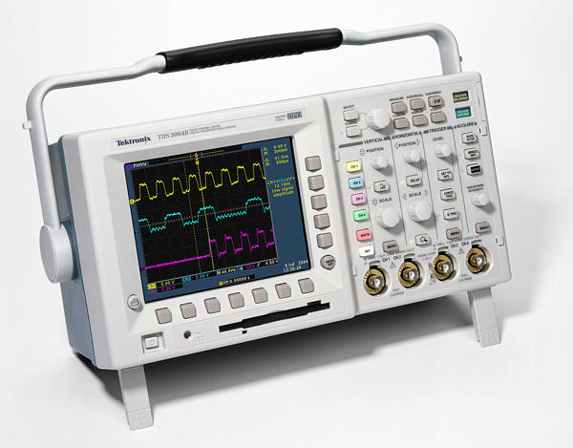
Figure 1. Tektronix 3012B Oscilloscope [1].

Display and Measurement Buttons are located in the top row of the oscilloscopes control panel, allowing selection of the waveform measurement, manual cursor, and display menus.

Waveform Selection Buttons are located on the left of the oscilloscopes control panel. These buttons are color coded to match the waveforms displayed on the oscilloscopes screen. Waveforms can be activated or selected by pressing these buttons.

Vertical Controls are located in the left dial column. The larger dial controls vertical sensitivity (V/div), while the smaller dial controls vertical position.

Horizontal Controls are located in the left center dial column. The larger dial controls horizontal sweep time (s/div), while the smaller dial controls horizontal position with respect to the trigger point.

Trigger Controls are located in the right center dial column. The small dial can be used to adjust the trigger level.

Menu Buttons are located below each of the above mentioned dial columns. When pressed, the menu for the corresponding control will be displayed on the LCD.
Initial Setup

- Before the oscilloscope can be adjusted to properly display the desired signal, test probes must be connected to the CH1 and CH2 input connectors (Figure 2).

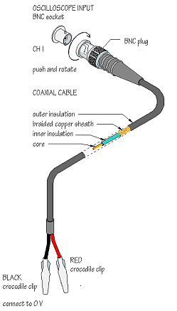
Figure 2. Oscilloscope probe hookup. [2]
Connection Procedure

- Align channels on the BNC cable to the corresponding notches on the BNC jack.
- Press the cable into the socket and twist clockwise until the cable locks into place.
- Connect the black alligator clip to the circuits ground.
- Connect the red alligator clip to the circuit where the desired signal is present.

Note: The alligator clips are not insulated. Take care when connecting probes to a circuit to avoid short circuits.

Display Adjustment

Viewing Waveforms
- Press the desired channel or function button from the waveform selection buttons.
- Using the vertical signal control, increase the vertical sensitivity of the waveform until the selected waveform occupies at least 3 vertical divisions.
- If the waveform peaks are off the screen, decrease vertical sensitivity until the selected waveform is fully within the screen.
- Adjust the horizontal time base so that several periods of the waveform are visible on the display.

Display Configuration

- Several display options are available for the user in order to provide a sharper signal and enable more accurate measurements.
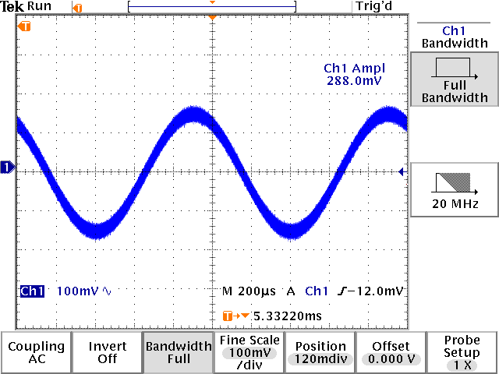
Figure 3. Full bandwidth signal.
Standard Setup (Figure 3)
- The default mode of the oscilloscope, funning on full bandwidth. Displayed signal represents the most resent sweep with no effect from previous sweeps.

Note: Full bandwidth allows the oscilloscope to capture events at very high frequencies, including noise. It may capture unacceptable levels of noise when measuring signals of less then 200 mV pp.

Bandwidth Limited Signal (Figure 4)
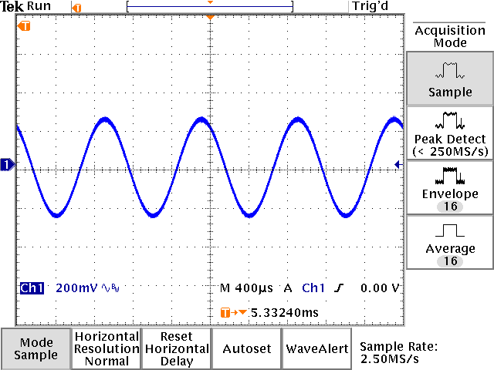
Figure 4. Bandwidth limited signal.
- Captured signal may be bandwidth limited to greatly reduce noise at frequencies lower then 20 MHz.

  - Select the desired channel and press the menu button under the vertical control column.
  - Select bandwidth from the bottom on screen key menu. (Figure 3)
  - Select 20 MHz from the right on screen keys.

Averaged Signal
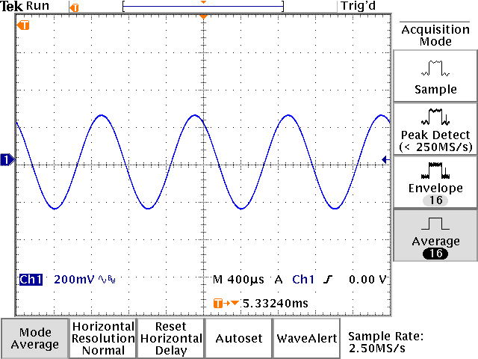
Figure 5. Averaged waveform.
- A repetitive signal with a stable trigger may be averaged to eliminate noise and provide a sharp display.

  - Press “Display” from the waveform selection buttons.
  - Press “Mode” on the bottom on screen keys.
  - Press “Average” on the right on screen keys.
  - Select the number of averages by rotating the cursor dial.

Note: An unstable trigger will cause an averaged waveform to distort, providing inaccurate readings. Verify that the triggering is stable using “Sample” before switching to “Average”.

Trigger Setup

- The oscilloscope trigger initiates the time base sweep so that subsequent repetitive waveforms overlap, and the display appears stationary.

Note: Triggering can be adversely affected by noise or modulated waveforms.

Triggering Display
- The Triggering Display alerts the user when a trigger is received. “Trig’d” will appear in the top right corner of the screen when a trigger is received.

Sweep Mode may be adjusted to provide a stable waveform or capture a single event.
- Press the menu button under the trigger control column.
- Select “Mode” from the bottom on screen keys.
- Select the desired mode from the right on screen keys.

- Auto triggering is used when a repetitive signal occurs periodically on continuously. Auto will sweep automatically is a trigger signal is not received within a preset time.
- Normal triggering is used when a repetitive signal occurs a-periodically. Normal will not sweep unless a trigger signal is received.
- Single triggering will sweep only once when a trigger signal is received. The captured waveform will remain on the display after the sweep is completed allowing capture of transient signals. The trigger in this mode may be reset using the Run/Stop button.

Trigger Coupling
- Press the menu button under the trigger control column.
- Select “Coupling” from the bottom on screen keys.

DC Triggering (Figure 6)
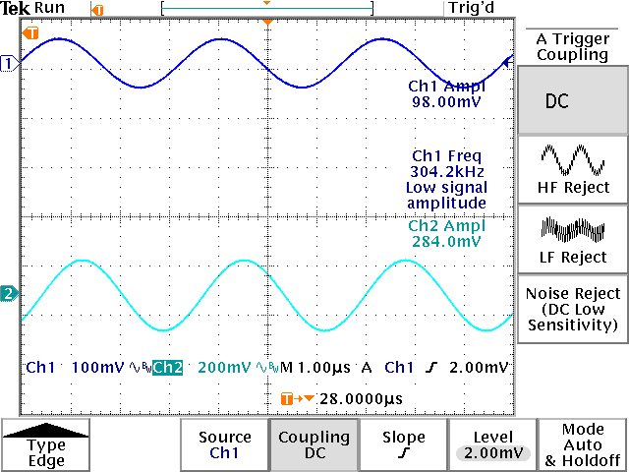
Figure 6. DC trigger.
- DC triggering is used when a repetitive signal occurs consistently and is noise free. The trigger occurs when the DC level crosses the preset value.

HF Reject
- Filters the trigger input with a low pass filter.
- HF reject should be used to stabilize the display for LF signal observation when a low amplitude HF signal is superimposed on a LF signal.

LF Reject
- Filters the trigger input with a high pass filter.
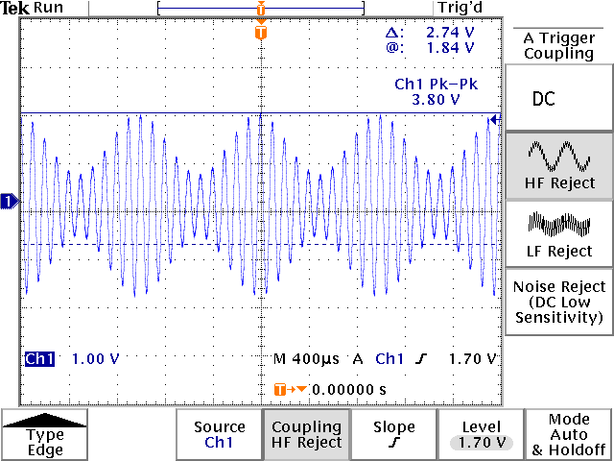
Figure 7. HF reject triggering.
- LF reject should be used to stabilize the display for HF signal observation when a low amplitude LF signal is superimposed on a HF signal.

Noise Reject
- Compensates for noise on the trigger channel input by averaging the incoming signal.
- Noise reject can be used to stabilize the display when a signal contains a component of random noise.

Measurement

- Automated measurements can be used to accurately obtain numeric information about a captured waveform.
- Measurements will only work properly with a stable trigger and are more accurate with a noise free waveform.
- Averaging the display greatly increases measurement accuracy.

Cursor Measurement
- Cursors can be used to manually measure signal properties.
- Cursor position is adjusted with the cursor control dial next to the measurement buttons.
- The Select button can be used to select the cursor to be adjusted.

Measurements
- Press the “Measure” button.
- Press “Select Measurement” from the bottom on screen keys.
- Select the channel to measure by pressing the corresponding channel button.
- Press “More _ of 6” on the right on screen key until the measurement of interest is displayed on the right menu.
- Select the given measurement to display on the screen by pressing the corresponding button on the right on screen menu.
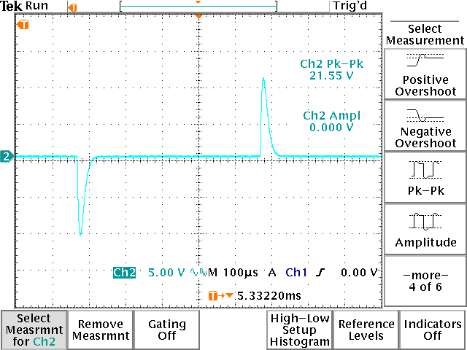
Figure 8. Amplitude and pk-pk.
Amplitude (Figure 8)
- Measures the steady state maximum and minimum levels of a waveform, ignoring transient overshoots.

Peak to Peak (Figure 8)
- Measures absolute maximum to absolute minimum levels of a waveform.

Note: Amplitude ignores transient overshoots, in figure 8 the measured amplitude is 0V, while the measured Pk-Pk is 21.55V.

Two Port Network Frequency Response
- Using amplitude measurements, the frequency response of a two port network can be determined.

- Connect CH1 to the input port and CH2 to the output port.
- Select amplitude measurements for CH1 and CH2.
- Vary input frequency while recording gain as determined by Av=Vo/Vi. When adjusting frequency make sure to keep at least one period of the signal on screen at all times.

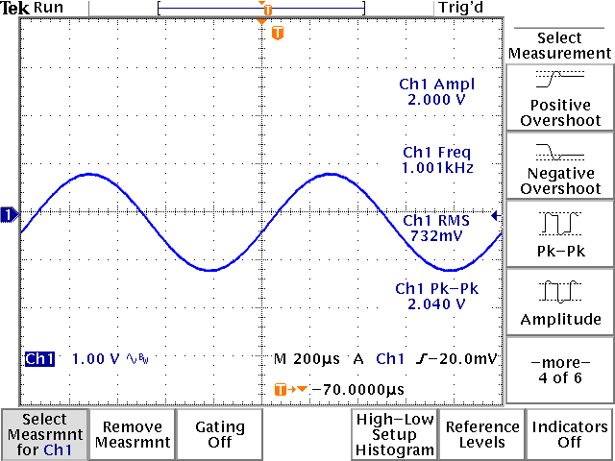
Figure 9. Frequency and RMS.
RMS Amplitude (Figure 9)
- Measures the RMS value of the captured waveform.

Frequency (Figure 9)
- Measures the frequency of a waveform. Measurement requires at least one period to be on the display.

Period
- Measures the period of a waveform. Measurement requires at least one period to be on the display.
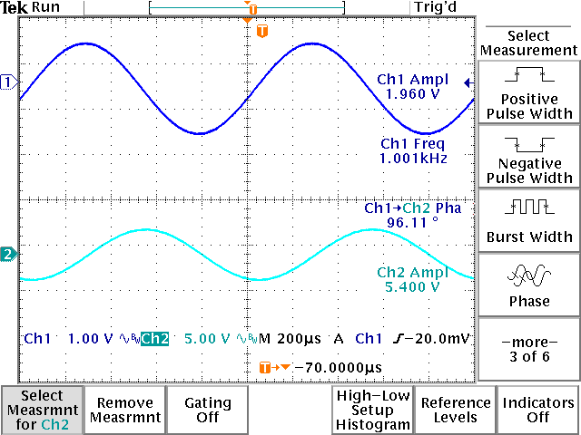
Figure 10. Phase measurement.
Phase (Figure 10)
- Measures the phase difference between two displayed signals.

FFT (Figure 11)
- Calculates Fourier frequency components using the FFT algorithm.

  - Press the math button on the waveform button column.
  - Select FFT on the bottom on screen keys.
  - Select rectangular on the FFT window button.
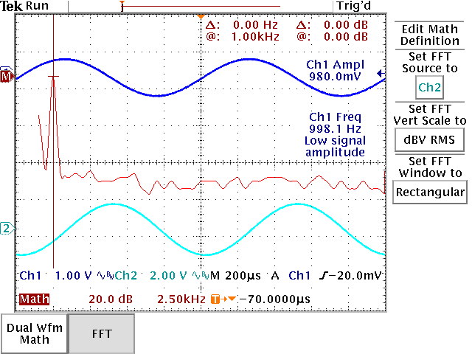
Figure 11. FFT measurement.
  - Adjust the frequency display range of the FFT display with the vertical sensitivity dial until the desired frequency component is in view.
  - Press the cursor button and select vertical bars.
  - Use cursor to determine the frequency of the fundamental frequency

Troubleshooting

During automated measurements, the following alerts may be displayed under a given measurement readout.

Low signal amplitude
During measurement a “low signal amplitude” warning indicates that the vertical sensitivity is not sufficient to provide accurate measurement of signal amplitude. Increase sensitivity until the signal occupies several vertical divisions.

Clipping
During measurement a “clipping” warning indicates that the vertical sensitivity or vertical position is set at a level where the peaks of the waveform are clipped by the top of the display screen. Adjust vertical sensitivity and position until the entire waveform is displayed within the vertical bounds of the display.

Low resolution
During measurement a “low resolution” warning indicates that the sweep time is not fast enough to provide accurate resolution of time based measurements. Adjust time base until the display contains less then 5 periods of a given signal.

No period
During measurement a “no period” warning indicates that the sweep time is to slow to display at least one period within the display. Adjust time base until the display contains more then 2 periods of a given signal.

[1] “Digital Phosphor Oscilloscopes,” Tektronix
http://www.tek.com/site/ps/0,,3G-12482-INTRO_EN,00.html

[2] "Using an Oscilloscope,"
http://www.doctronics.co.uk/scope.htm

