Technical Design Report: Passive Analog Filter Implementation.

Andrew Seltzman
Georgia Institute of Technology
Department of Electrical Engineering
Executive Summery

A series of passive analog filters were designed to meet frequency response characteristics provided by Buzz Audio. This report contains all design specifications and theory relating to the implementation of the bandpass and notch filters described herein, as well as simulated and experimental results.
A Bandpass filter has been designed to provide greater than 6db attenuation at frequencies below 1 kHz and above 100 kHz while allowing carrier frequencies of 5 kHz, 14 kHz, and 30 kHz to pass with less than 2dB attenuation, and a notch filter has been designed to provide greater than 6db attenuation at 12.8 kHz while allowing frequencies greater then 16 kHz and less than 9.6 kHz to pass with less than 2 dB attenuation.
The bandpass filter exceeded requested specifications, providing superior attenuation at 100 kHz and 1 kHz, while passing the carrier frequencies of 5 kHz, 14 kHz, and 30 kHz at greater than requested gain.
The notch filter attenuates the requested 12.8kHz to below -6dB, however due to the low Q factor, the filter is unable to meet specifications at 9.6kHz and 16 kHz.
While the bandpass filter is highly recommended for further testing, the design of the notch filter will require modification to increase the Q factor in order to meet specification. The use of the present combination filter is not recommended due to its attenuation level at the 14kHz carrier frequency.
Introduction

A series of passive analog filters were designed to meet frequency response characteristics provided by Buzz Audio. Bandpass and notch filters have been designed and tested in order to determine accuracy in meeting cutoff and pass frequency requirements.
A Bandpass filter has been designed to provide greater than 6db attenuation at frequencies below 1 kHz and above 100 kHz while allowing carrier frequencies of 5 kHz, 14 kHz, and 30 kHz to pass with less than 2dB attenuation, and a notch filter has been designed to provide greater than 6db attenuation at 12.8 kHz while allowing frequencies greater then 16 kHz and less than 9.6 kHz to pass with less than 2 dB attenuation.
This report contains all design specifications and theory relating to the implementation of the bandpass and notch filters described herein, as well as simulated and experimental results. This report recommends modifications for future designs along with a detailed analysis of passive filter performance.

Design Specifications

Bandpass Filter
Type | RC
Order | First
Pass Frequencies (Gain > -2 dB) | 5 kHz
 | 14 kHz
 | 30 kHz
Lower Block Frequency (Gain <-6 dB) | 1 kHz
Upper Block Frequency (Gain <-6 dB) | 100 kHz
Notch Filter
Type | LRC Parallel
Notch Frequency (Gain <-6 dB) | 12.8 kHz
Lower Pass Frequency (Gain >-2 dB) | 9.6 kHz
Upper Pass Frequency (Gain >-2 dB) | 16 kHz

Design Theory and Methodology

A passive RC bandpass filter was implemented to transfer the required carriers while blocking frequencies out of the stated range. The implemented bandpass filter (Figure 1), consists of a lowpass filter cascaded into a highpass filter. The upper and lower cutoff frequencies for a bandpass filter are given by $f=\frac{1}{2π\text{RC}}$ provided that $R_{1}C_{1}+R_{2}C_{2}\text{>>}R_{1}C_{2}$ where R1 and C1 are the lowpass section and R2 and C2 are the highpass section. Using the above formula, a first order lowpass filter was constructed and connected to a 1k Ohm output load. Due to the loading on the output, the filters transfer function is altered, and the above equation no longer gives a valid approximation of filter frequency.
To correct for output loading and allow proper signal transfer to subsequently cascaded filters, the series input resistance was chosen to be a low value, providing the highest voltage drop over the capacitor portion of the low pass filter, and improving signal gain. The resistor was held constant and the capacitor was adjusted to provide the proper high frequency cutoff, while allowing transfer of the required carrier frequencies with minimal loss.
The second stage highpass filter was subsequently added, and the filter was again adjusted to match specification by altering the series capacitor to adjust low frequency cutoff, while a high value parallel resistor was held fixed. A high value resistor was chosen to add negligible conductance to the output load, thus improving gain.
An RLC notch filter (Figure 1) was implemented to block a given carrier frequency while allowing transfer of all other signals with minimal signal loss. An RLC parallel filter will have a notch frequency given by $\text{fo}=\frac{1}{2π\sqrt{\text{LC}}}$ and a quality factor of $Q=\frac{\text{fo}}{Δf}=\frac{2π\text{foC}}{G}$, where G is the conductance of the parallel resistor. A 3.3mH inductor was chosen as the inductive component while a 1k Ohm parallel resistor remained at a fixed value during testing. The capacitor was varied from its theoretical value until the notch frequency was centered at 12.8 kHz. The resistor was increased until the required notch frequency was attenuated at the specified level of -6 dB.
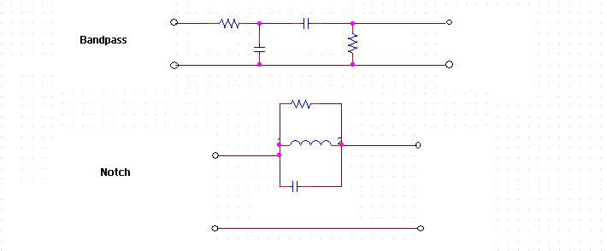
Figure 1. Bandpass and notch filter circuit.
A combination filter was implemented by cascading the bandpass and notch filters to allow carrier frequencies within the passband to be selectively attenuated. The notch filter was coupled to the output of the bandpass filter, and the lowpass filter parallel capacitor was reduced in value to compensate for the location of the notch filters attenuation maxima.

Design Details

All schematics in this section include a 50 Ohm resistor to simulate function generator output impedance, as well as the 1k Ohm resistive load specified in the design requirements. Bandpass filter schematic is shown in Figure 2. The 0.055uF capacitor was implemented as a 0.022uF in parallel with a 0.033uF capacitor. Likewise, the 0.066uF was implemented as two 0.033uF capacitors in parallel.
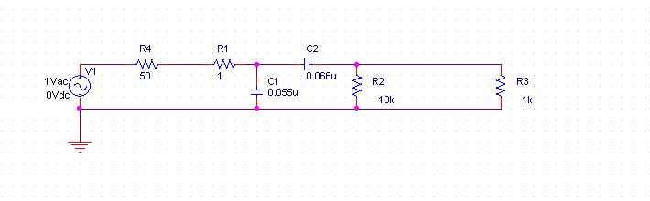
Figure 2. Bandpass filter schematic.
The notch filter is implemented as depicted in Figure 3.
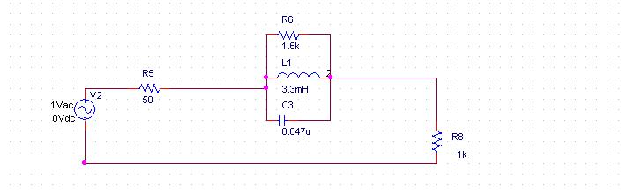
Figure 3. Notch filter schematic.
The cascaded bandpass and notch filter is implemented as the output of the existing bandpass filter connecting to the input of the notch filter. The bandpass filter has been modified by reducing the parallel capacitor to 0.033uF to compensate for the response of the notch filter.
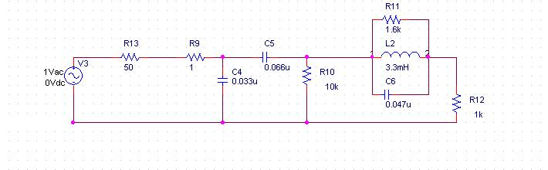
Figure 4. Combination filter schematic.

Table 1: Part Summery for Notch and Bandpass Filters
Bandpass Filter
Component | Quantity
Resistor 1 Ohm | 1
Resistor 10k Ohm | 1
Capacitor 0.033uF | 3
Capacitor 0.022uF | 1
Total | 6
Notch Filter
Component | Quantity
Resistor 1.6k Ohm | 1
Capacitor 0.047uF | 1
Inductor 3.3mH | 1
Total | 3

Design Testing – Simulated and Experimental Results

The following section contains simulated and experimental results for the requested filter implementations.

Simulated:

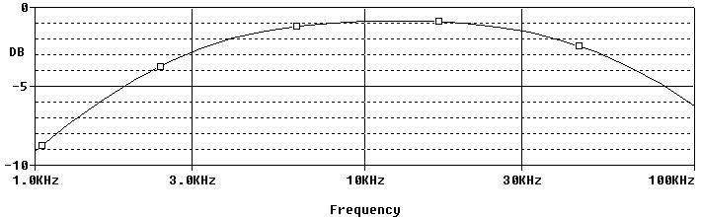
Figure 5. Simulated bandpass filter gain.
The simulation of the bandpass filter (Figure 5) yielded an attenuation of -9.11 dB at 1 kHz and an attenuation of -6.26 dB at 100 kHz, while attenuating the required carrier frequencies of 5 kHz, 14 kHz, and 30 kHz at levels of -1.5 dB, -0.86 dB, and -1.49 dB, respectively. The low input resistance and capacitor selection yield a filter that produces 0.5 dB of gain greater than requested at the required carrier frequencies, while providing greater than the necessary attenuation at the stop bands.
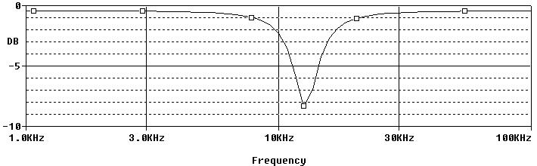
Figure 6. Simulated notch filter gain.
Simulation of the notch filter confirms that the given design is unable to meet all design specifications. Due to the low Q factor of the filter, the width of the attenuation notch spans past the desired stop frequencies, attenuating 16 kHz to the -2.48 dB. The filter meets the required pass frequency of 9.6 kHz with a -1.9 dB attenuation and provides -8.4 dB attenuation at 12.8 dB

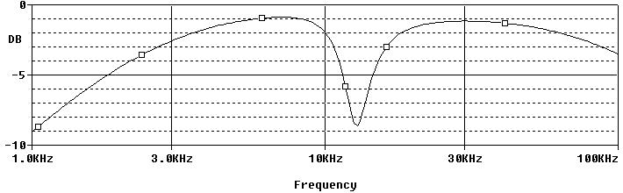
Figure 7. Simulated combination filter gain.
Simulation of the combination filter (Figure 7) showed that the design would fail to meet the specification of passing 14kHz due to the proximity of the attenuation of the notch filter. Although compensating by reducing the lowpass filter capacitor value allowed the filter to pass the 30kHz carrier as requested and attenuates the 1kHz frequency to below the requested value, however the filter is not able to attenuate a 100kHz frequency to below -6dB.

Experimental:

Figure 8. Bandpass filter gain.
Testing of the bandpass filter (Figure 8) showed a transfer of carrier frequencies with 0.5 dB greater gain then requested and superior attenuation below 1kHz and above 100kHz.
Figure 9. Notch filter gain.
The notch filter attenuates the requested 12.8kHz to below -6dB, however due to the low Q factor, the filter is unable to meet specifications at 9.6kHz and 16 kHz.
Figure 10. Combination filter gain.
The combination filter performs as the simulation predicts, failing to block 100kHz, and failing to pass 14kHz frequencies.

Conclusion and Recommendations

The bandpass filter exceeded requested specifications, providing superior attenuation at 100 kHz and 1 kHz, while passing the carrier frequencies of 5 kHz, 14 kHz, and 30 kHz at greater than requested gain. The bandpass filter is highly recommended for applications of similar output load while connected to a 50 Ohm impendence input. Due to the close tolerances to which the bandpass filter was matched, it is recommended to keep the input impendence and output load as close to the stated values as possible to maintain specified filter performance. This filter will consistently meet design specifications if operated within the recommended parameters and will provide accurate filtering for the desired frequencies.
Due to the limitation of using a 3.3mH inductor, the Q factor of the notch filter could not be adjusted to meet all required specifications. While the notch filter will meet the 9.6kHz pass frequency requirements and 12.8kHz attenuation requirements, it is not recommended to implement this filter where the 16kHz attenuation level is critical, as it falls 0.5dB below the requested level. It is also not recommended to implement this design where a narrow stop band is required, due to the low Q factor of this filter.
Due to limitations generated by the notch filter, the combination filter will not meet specifications. The proximity of the 12.8kHz cutoff frequency, combined with the low Q factor of the notch filter prevent the 14kHz carrier frequency from being transferred with suitable gain. Further, modification of the combination filter to pass the 30kHz carrier prevents the system from preventing the required -6dB attenuation level at 100kHz
While the bandpass filter is highly recommended for further testing, the design of the notch filter will require modification to increase the Q factor in order to meet specification. The use of the present combination filter is not recommended due to its attenuation level at the 14kHz carrier frequency.

